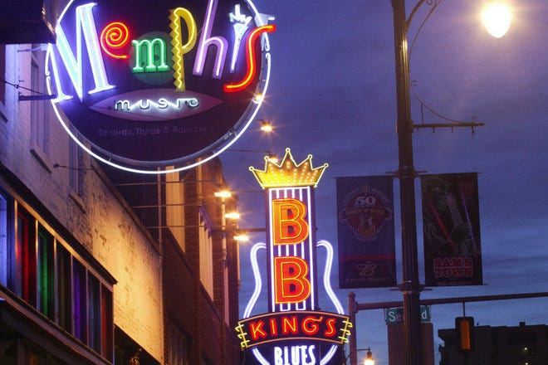  Pub crawl and poker run  ON  Beale street  - friday MAY 13th, 2022  Buy drinks (cokes or southern sweet tea is fine too) and get a card at a majority of bars on Beale Street. Find the five Enchanted Lanterns and get a pic with it and a card for each found. Scavenger hunt style that will help you earn more cards. The more you enjoy Beale the more chances you have for cards. Prizes for top Players | Join us at the Peabody Hotel to watch the World Famous Ducks  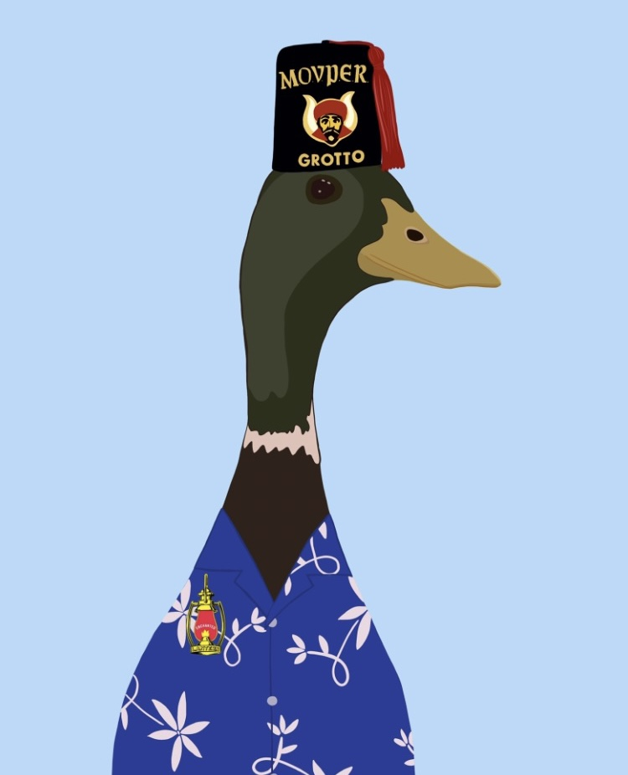  Join us to see the World Famous Peabody Hotel Ducks 5:00pm
77th Annual Southeastern Grotto Association
May 13th – 14th
Memphis, Tennessee
“Blue Hawaii”

President Banquet Luau
Roasted Whole Pig
Pancet Lumpia
Eggrolls Chicken
Desserts and lots of Fresh Fruit
$50 a Person and Dance to Follow

This Convention is Dedicated to Grotto. It is for Fun, Fellowship, Family and Ducks.
1. The Grotto Golf Tournament. Mix and mingle with Memphis area Masons and find new friends and Brothers maybe a new Prophet.
2. For the non-golf there can be a tour of the Old Dominick Distillery, the cigar emporium, Gus’s Chicken and the Bass Pro Shop.
3. For the Ladies, the Botanical Gardens, the Lichterman Center, and the boutiques of Cooper Young District with antiques and fashion.
4. And for the Children, the Memphis Zoo, the Children’s Museum, and Pink Palace with a Planetarium.
Several options are available but, during the Convention, there is Beale Street. There will be a Pub Crawl / Poker Run. Cards will be available from several locations on Beale and options to get extra cards are available if you spot the Enchanted Lanterns or photos that may or may not incriminate you. This event last the whole convention with the winner crowned on Saturday night at the Dance.
Bar-B-Que for Friday at Lunch. Catfish on Saturday for Lunch. Hospitality at Zaman Grotto with the hotel just a few miles away but drivers to take you back and forth if you Grotto too hard. A banquet fitting for a KING. A LUAU. And a Dance. Blue Hawaii. Wear Hawaiian attire or blue attire. Or dress like Elvis, your choice.
Several tours are available for Graceland, Stax Records and Blues Museum, Sun Studio, Haunted Tours and DUCKS.

Hope to see ya’ll there!!!!!

Sparkie Sparks
901-489-4161

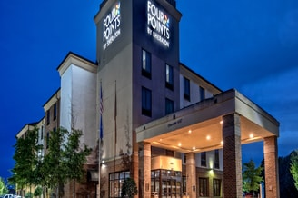

Four Points by Sheraton Memphis - Southwind

4090 Stansell Court Memphis, Tennessee 38125 15 Miles to MEM airport
- Business center
- Fitness center
- Free high-speed internet
- High-speed internet at a price
- Parking
- Pool
- Restaurant on-site
Rate available: 05/11/2022 to 05/15/2022
From $129 USD/night

Here's your reservation link your guests can use to make reservations:
Book your group rate for Grotters of North America
You will find the information for your online reservation link below. If you have questions or need help with the link, please do not hesitate to ask. We appreciate your business and look forward to a successful event.
Event Summary:
Grotters of North America
Start Date: Wednesday, May 11, 2022
End Date: Sunday, May 15, 2022
Last Day to Book: April 1, 2022
Hotel(s) offering your special group rate:
- Four Points by Sheraton Memphis - Southwind for 129 USD per night
Book your group rate for Grotters of North America
Here's your reservation link your guests can use to make reservations:

Convention Program Ads

Send to:
Zaman Grotto SEGA Convention
Attn: Sparkie Sparks, PM
585 Atoka-Munford Ave
Atoka, TN 38004
Please check one:
Full Page Add $120
Half Page Ad $75
1/4 Page Ad $45
Inside Front Cover $200
Inside Back Cover $150
Outside Back Cover $200
Make checks payable to Zaman Grotto Convention Fund
Name:
Address:
City:
Phone:
Message for Ad.:
Or send ad to sammysparks@yahoo.com

Full Page is 8”x5”

Howdy fellow Prophets of the South Eastern Grotto Association and everyone in the Realm
I would like to extend an invitation to the SEGA Annual Session May 12-14, 2022.
Attached in this package are the following forms:
Registration Package for 2022 SEGA (South Eastern Grotto Association) Convention
(Hotel Information Attached)
Thursday
May 12, 2022 Registration
Golf Tournament (a few miles from the Grotto) with refreshments at Zaman Grotto right after
Visit www.timbertrussgolf.com for course information
Shotgun start at 8:30am

HOSPITALITY AT ZAMAN GROTTO
7818 E. HOLMES RD
MEMPHIS, TENNESSEE 38125
May 13, 2022 Registration
Hospitality
Friday
May 13, 2022
Registration
Officers Meeting
Opening Ceremonies
Business session
BBQ Lunch at Zaman Grotto

HOSPITALITY AT ZAMAN GROTTO
7818 E. HOLMES RD
MEMPHIS, TENNESSEE 38125

Saturday
May 14, 2022
Business meeting
Necrology and Memorial Service
Enjoy Catfish Lunch at Zaman Grotto
Explore Memphis and make this trip yours
ZAMAN GROTTO
7818 E. HOLMES RD
MEMPHIS, TENNESSEE 38125
Presidents Banquet (Cash bar available)
Parade of Enchanted Lanterns
Installation of Officers
Blue Hawaiian Dance
Sunday
May 15, 2022
Departure - If any assistance is required, please provide information
for specific assistance
While traveling please take your time and be safe. If in the event of an emergency while traveling
please contact myself, or one of the Zaman Grotto officers.
Sincerely,
Earnest “Sparkie” Sparks, PM
President, 2022 SEGA Association

The 77rd Annual Southeastern Grotto Association Convention
May 12-15 2022
Memphis, Tennessee
Hosted by Zaman Grotto
Registration Fees
Before May 1, 2022 …………………………………………………………………………………… Couples $ 260.00 Singles $ 130.00
After May 1, 2022…………………………………………………………………………………..……Couples $ 275.00 Singles $ 145.00
Registration includes Luncheon on Friday (BBQ) and Catfish Dinner for Lunch on Saturday
Presidents Banquet (Luau) on Saturday…………………………………………………………………………………… $ 50.00 per person
Golf Tournament (Shotgun Start at 8:30 am with refreshments (beer / soft drinks and hotdogs and hamburgers) ……$50.00
Make Check payable to: Zaman Grotto Convention Fund and mail this completed form to:

Earnest “Sparkie” Sparks, PM
SEGA President
585 Atoka-Munford Ave
Atoka, TN 38004
Phone # 901-489-4161
sammysparks@yahoo.com

Feel Free to pay by PayPal using sammysparks@yahoo.com
CashApp $sparkiesparks
And you can text a copy of your registration to my phone as long as you verify that I received it.
Registration Fee …………….. $ _________________
Luau Meal ……..………………. $ _________________
Golf Tournament……………….…$ ___________
Total ………………………………..$ _________________
*****************PLEASE PRINT*******************
Name:____________________________________________________

Title: _______________________ Ladies Name: __________________

Address: __________________________________________________

City: _________________________ State: ___________ Zip: ________

Phone: ________________________ Grotto: _____________________

Email: _____________________________________________________

Where a great game of golf is a gimme
Looking for a golf club that is as much about fun as it is about golf? Come see the all new Timber Truss Golf Course, Formerly Plantation Golf Club, Timber Truss delivers the same great course with an all new clubhouse and grill, as well as, a modernized pro shop, brand new fleet of golf carts and an outdoor lounge. This 180-acre property is suitable for tournaments, banquets and business meetings.
This is more than golf.
Timber Truss is located at
9425 Plantation Road, Olive Branch MS

Timber Truss Golf Course
9425 Plantation Road,
Olive Branch MS
Phone: 1-662-850-6157
E-mail: timbertrussgolf@gmail.com

Visit www.timbertrussgolf.com for course information

8:30 Shotgun Start
Prizes for top Team
$50 that includes Range Practice Balls and Cart Rental

